Revision History
Date | Version | Description | Author
<22/10/2019> | <1.0> | Sequence Diagram, System requirements specification, Changed the Use Case Diagram for Version 2,  Added a User and a System Requirement | <Barış Karaer>
<22/10/2019> | <1.0> | Use Case Diagram, User requirements specification | <Alper Sayan>
<03/11/2019> | <1.0> | System Overview Change, System Architecture Diagram | <Erdem Gönül>
<03/11/2019> | <1.0> |  | <Yağız Naz>

TABLE OF CONTENTS
Revision History 1
1 INTRODUCTION 3
1.1 Document overview 3
1.2 Abbreviations 3
1.3 References 3
1.4 Conventions 3
2 REQUIREMENTS 5
2.1 User Requirements Specification 5
2.2 System Architecture 5
2.3 Use Cases and Usage Scenarios 5
2.4 System Requirements Specification 5

INTRODUCTION

Document overview

This document presents the software requirements specifications of Hospital Patient Management software development project. It describes functional requirements, quality requirements, constraints, use cases, and usage scenarios. It also provides an overview of the system architecture.

System overview

The system needs a web page, a server, a server side application to run on this server, and a database. The functions of the system can be defined as adding, organizing and deleting patients, doctors and appointments. However, there is a page where doctors can see, approve and list their appointments on a particular date. It includes a system where doctors can see complaints and diagnoses of patients and the ability to leave comments and notes on them.
Authorization is only done by doctors or an admin. Patients wont be able to login to the system. It will be used by doctors to review their patients, see their patients appointments and manage them. An admins job is for maintenance, appointment addition if a doctor is busy and for testing purposes.

Abbreviations

HPMS: < Hospital Patient Management System >
UML: Unified Modeling Language
SRS: Software Requirement Specification
STP: Software Test Plan
…

References

# | Document Identifier | Document Title
[R1] | ID | Add your documents references.  One line per document.

Conventions
Requirements listed in this document are constructed according to the following structure:

SRS-HPMS-000
Description of HPMS-000 requirement
Version of HPMS-000

Every system requirement id includes the id of the corresponding user requirement as a prefix.

SRS- HPMS -000.1
Description of HPMS -000.1 system requirement, which is related to the user requirement HPMS-000
Version of HPMS -000.1

REQUIREMENTS

User Requirements Specification

SRS-HPMS-001
HPMS software shall be able to delete patient,doctor and appointments in the database .
V1.0

SRS-HPMS-002
HPMS software shall be able to give the users the option to list patients, doctors and appointments .
V1.0

SRS-HPMS-003
HPMS software shall give the users the option to edit the doctor,patient and appointment inputs that was previously filled.
V1.0

SRS- HPMS -004
HPMS software should let doctors and admins see some problems patients have faced and make a reply or comment to that post.
V1.0

SRS- HPMS -005
HPMS software should not let an admin or a doctor add an appointment date that is occupied.
V1.0

SRS- HPMS -006
HPMS software should not let any users into the home page without any authorization.
V1.0

SRS- HPMS -007
HPMS software should let a user see his/her profile and edit his/her personal information but not let a user edit important informations like birth date, blood type, name and surname.
V1.0

SRS- HPMS -008
HPMS software should let a user to create his account as a doctor or a system admin.
V1.0

SRS- HPMS -009
HPMS software should let a doctor create an account but it should not let anyone create an account (Hospital should add their staff to their database). System should check if there is a doctor like that in their database so there will be no intruders.
V1.0

System Architecture

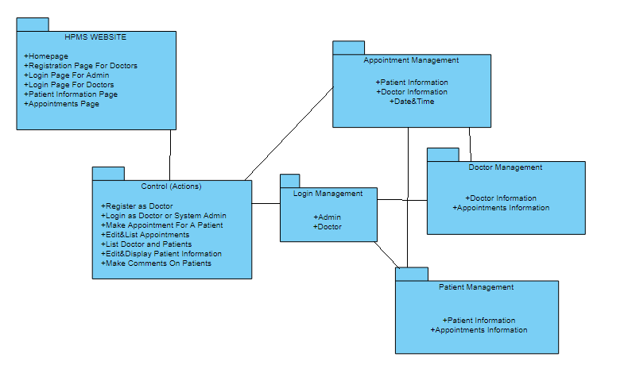

Use Cases and Usage Scenarios

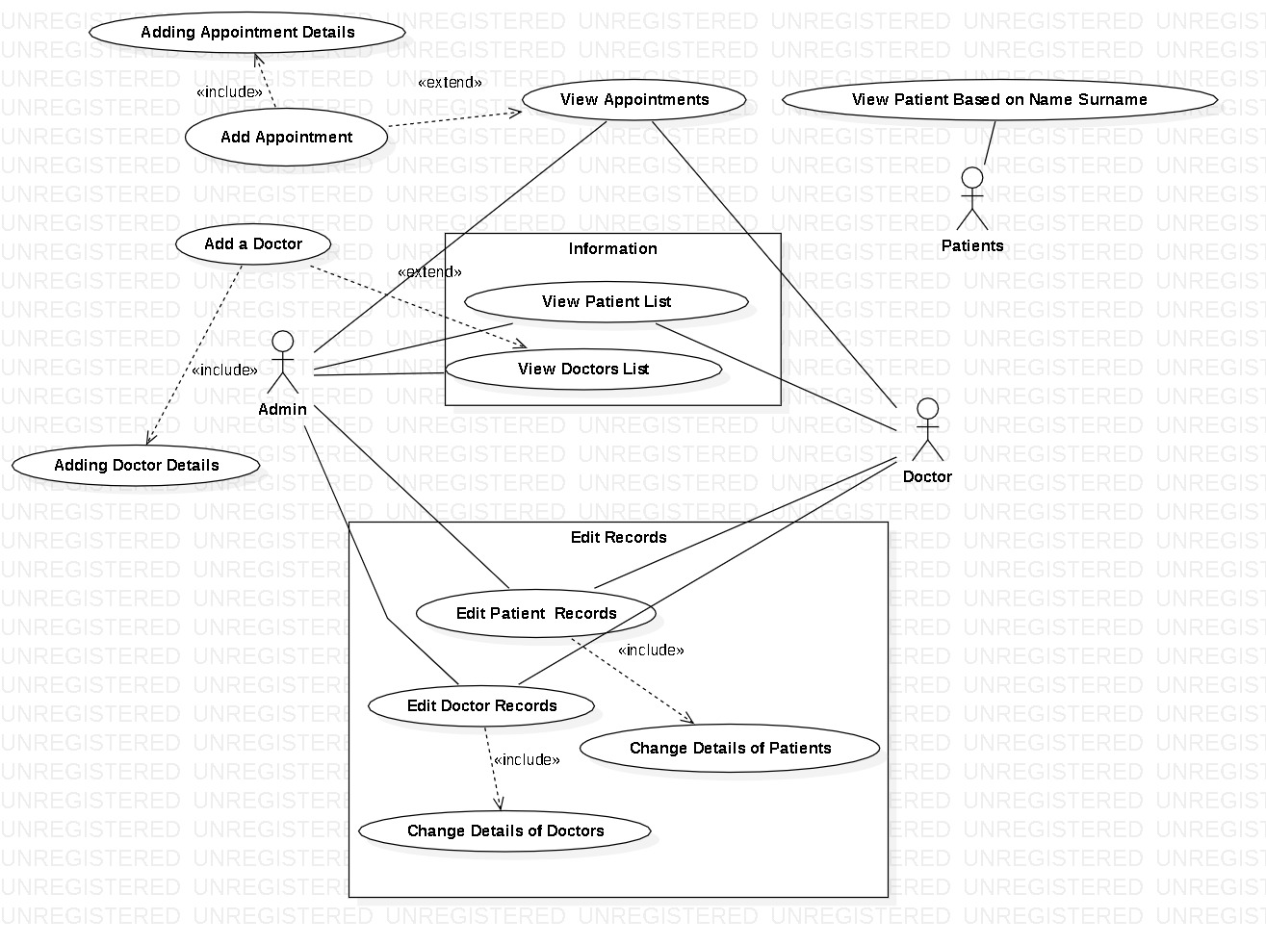

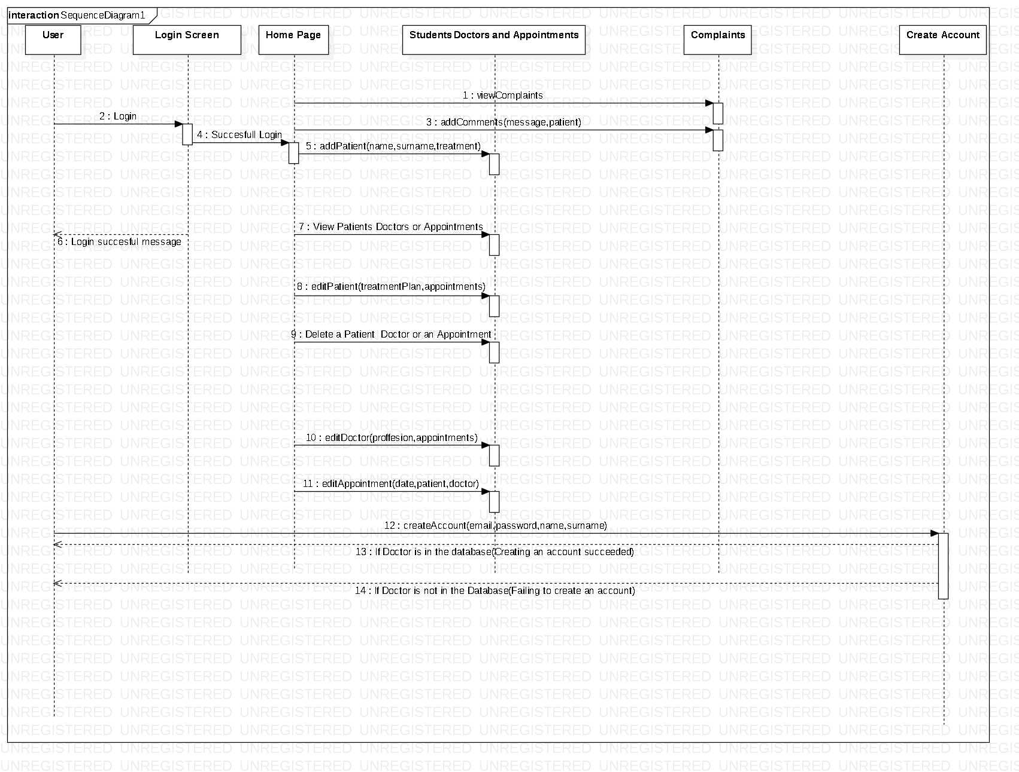

System Requirements Specification

SRS-HPMS-001.1
Functional
HPMS ensures that the displayed patient lists data are the same as read in the input files (Database).
The patient’s data are:
- Name,
- Surname
- Date of birth,
- Blood Type
- Address
- Telephone Number
- Treatment Plan
- Appointments
- Medicine Problems
- Identity Number
V1.0

SRS-HPMS-001.2
Functional
HPMS ensures that the displayed doctors lists data are the same as read in the input files (Database).
The doctor’s data are:
- Name,
- Surname
- Date of birth,
- Address
- Telephone Number
- Patients
- Appointments
- Medicine Problem Replys
- Identity Number
V1.0

SRS- HPMS -002.1
Non-Functional
HPMS logs every appointments that is added into the database:
- It saves every date,appointed doctor and patient,what the treatment is about
- Gives them a unique id to list them later on.
V1.0

SRS- HPMS -003.1
Non-Functional
HPMS adds every patients and doctors details to the database and gives them a unique id:
- It saves every personal information that was previously entered and inserts them into a table in the database,
- Gives them a unique id to list them later on.
V1.0

SRS- HPMS -004.1
Non-Functional
HPMS sees the difference whether a doctor or an admin logged in and displays different types of functions in the front end.
V1.0

SRS- HPMS -005.1
Non-Functional
HPMS logs out and returns to the login page if the session is over.
V1.0

SRS- HPMS -006.1
Non-Functional
HPMS does not execute if any HTTP errors happen while database insert,delete,select or update.

Functional
Displays the HTTP error with a pop-up for the user to see.
V1.0

SRS- HPMS -007.1
Non-Functional
HPMS does not execute any queries if an input like select or a text box is empty (not filled).

Functional
Informs the user with a pop-up that each input shall be filled.
V1.0

SRS- HPMS -008.1
Non-Functional

Only doctors and admin can register or login to the system. Appointments are made over the phone or face to face via doctors or admin.

SRS- HPMS -009.1
Non-Functional

Users will be able to register and log in to the system using their email addresses or phone numbers. Two users will not be able to register with the same mail and phone number. In order to register you must be a doctor or system admin.
Functional

If you want to register with the same mail or phone, you will get a pop up error.

SRS- HPMS -0010.1
Non-Functional

Users won’t be able to register if a doctor name is not in the database.

Functional

If a user wants to create a doctor account but the data of email, name or surname doesn’t match the database information of the doctor datatable, the user will get a pop up error.

